**ADVANCED SOFTWARE ENGINEERING**

**CS5551**

**PROJECT PLAN (PG-7)**

**TITLE: MYSPARETIME.COM**

By: Beeravalli, Ramakrishna Reddy (Class ID: 7)(TL)s

Mayathari, Vijay Kumar (Class ID: 23)

Dubbaka, Medha (Class ID: 13)

Sura, Sindhuja (Class ID: 36)

**I. Introduction**

Everyone likes to keep themselves busy most of the time. But, there would be instances where a person is left idle. This joblessness makes a person much bored. What if there is an application, where a person can search for work- either to pass time or make money instantly during the spare time. Our project intends to be a resource for them, where a user can make an online search of activities which he/she would be interested in, to make a wise utilization of free time. Often people are interested in doing many activities but they don’t have proper idea regarding when and where to attend them. Our application provides a platform for them by listing them all the available activities. There is choice to choose from a wide-range of activities locally or per-preference. Our project also integrates other features, making it more resourceful.

**II. Objectives and Goal of the Project**

* Goal

The main goal of our project is to create an application where-in a user can search for activities which can be done during the spare-time either to utilize free-time or make money based on their preferences.

* **Objectives (Specifically)**

The application which we are designing is compatible as a web-application or on mobile interface. The user upon validating their credentials can navigate to fields- Pass time or Make Money. Further, the application navigates to page which has search columns where a user can search for work, based on his/her preferences. This application would be useful for not only people who would like to make a wise utilization of free-time, but also it can help the employers who are actively looking for people to a great extent. It serves as a one-stop application for both searching and hosting jobs/activities.

* **Significance**

Significance of this application is that the user can make a quality utilization of spare time, improvise his/her skills and abilities, make a favorite hobby, and also can make money. Also, the employers/hosts find it a right platform to search for volunteers/people who can perform their work right-on time with minimal and reasonable effort. One of the advantages involved in our application is that users can have the scheduling freedom and flexibility.

**III. Project Background and Related Work**

**Existing work:**

http://www.peopleperhour.com/static/how-it-works-buyer

<https://www.odesk.com/>

<http://www.visitokc.com/events/this-month-in-okc/>

**Comparison**

Our application is different from others because the user can search for listings of activities based on his/her search preferences. The other applications like Peopleperhour.com, etc. is aimed at generating Part time income, also they surcharge a certain amount of percent on the pay earned by the user. But our application is open source and doesn’t involve in any third party charges. The application with its main aim to make a clever implementation of spare time based on time and hobby preferences. Also, this application provides a kind of entertainment with the inclusion of new features on the way.

**IV. System Proposed**

**Requirement Specification:**

* **Functional:** Application will have a record of Employers/Hosts who constantly update the requirements and offer work to those who register in their activity. Also, communicating with the event managers locally to collect data about the events, functions, seminars, workshops etc. and categorize them based on the Free or Paid Entrance to attend. Google maps service would be useful to determine the distance and time factors.
* **Non-functional:**

**Requirements of System:**

OS: Windows /Linux

RAM: 2GigaBytes or even more

Web Development Project

**Version of Android Device:**

Ram: 4 GB internal storage

ANDROID Device Version: Least Version of 4.3

* **Business Process/Workflow analysis**
* **Technical/business Requirements**

IDE: eclipse ADT (to run android application), eclipse Kepler/juno

ASP.NET with C#, JQuery, JavaScript

HTML5, Android for Mobile UI

SQL Server on Back End

**Framework Specification:**

* **Assumptions and Principles**

Assumptions made are that there would be events happening round the corner and usually many events occur on Holidays or weekends. Also, we assume that there is genuineness of the payment offered by the Employers based on the hourly work. There would also be no issues from the Data Analysis.

* **System Architecture Diagram**

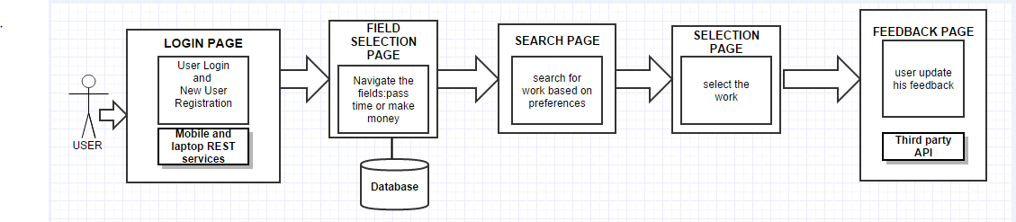

**System Specification**

1. **Existing Services:**

Map Services from Google Maps

<https://www.google.com/maps/preview?q=umkc&ie=UTF-8&ei=rw8vVL68NsSxyASJxoGgAQ&ved=0CAgQ_AUoAQ>

**ii) New Services to be built**

**Class diagram**

**WE NEED TO DRAW A CLASS DIAGRAM HERE USING RATIONAL RHADOPSY**

**Sequence diagram**

**WE NEED TO DRAW A CLASS DIAGRAM HERE USING RATIONAL RHADOPSY**

**Service Specification**

* The application is informed about the current and happening events within the prescribed city limits.
* Upon the screening of entries from the employers/ hosts, the application checks if the events/jobs are accessible to everyone.
* If the event doesn’t match as per the prescribed conditions, it is not listed on the Search Data.
* The User can search for listings based on the Requirements.
* The User is free to access the listings and can contact for further Info.

**Operational description:**

* The system checks for authorization from both the Employee and the Employer Side.
* Then, the system receives the Search fields from the Employee and categorize data based on their preferences.
* The display consists of data which is based on priorities, accessibility and other factors.
* The system receives data from the hosts/Employers and validates before forwarding to the Employees/Users.
* The data is not circulated further if the validation fails.
* The user hits the right search list and acknowledges his/her attendance to the event or his/her interest to take up the job.

**Input/output for services**

* **Constraints/exceptions**
  + Checking for genuineness of the Job offered is the biggest constraint, as it would affect the credibility of application itself.
  + The other constraint would be from the user side. The User can create multiple logins and multiple acknowledgements making it hard for the database to maintain the data.

**Service flow/alternative flow**

* **Priorities (degree of importance, difficulty, etc.)**

The first Priority is to make the application easy to navigate, attractive, and user friendly**.**

Collection and updating data on-time is the next important step.

Deploying the website on different platforms and creating awareness of the service is also important.

**V. Plan by Services (using ScrumDo)**

**VI. Risk management**

* **Technical/business Requirements**

Front end: Java, C#, HTML5, CSS3, JavaScript, jQuery, Android framework

Back end: Sql server.

**VIII. Bibliography**

[1] http://www.peopleperhour.com/static/how-it-works-buyer

[2] <https://www.odesk.com/>

[3] <http://www.visitokc.com/events/this-month-in-okc/>

[4] <http://developer.android.com/guide/faq/framework.html>

[5] <http://www.tutorialspoint.com/android/>